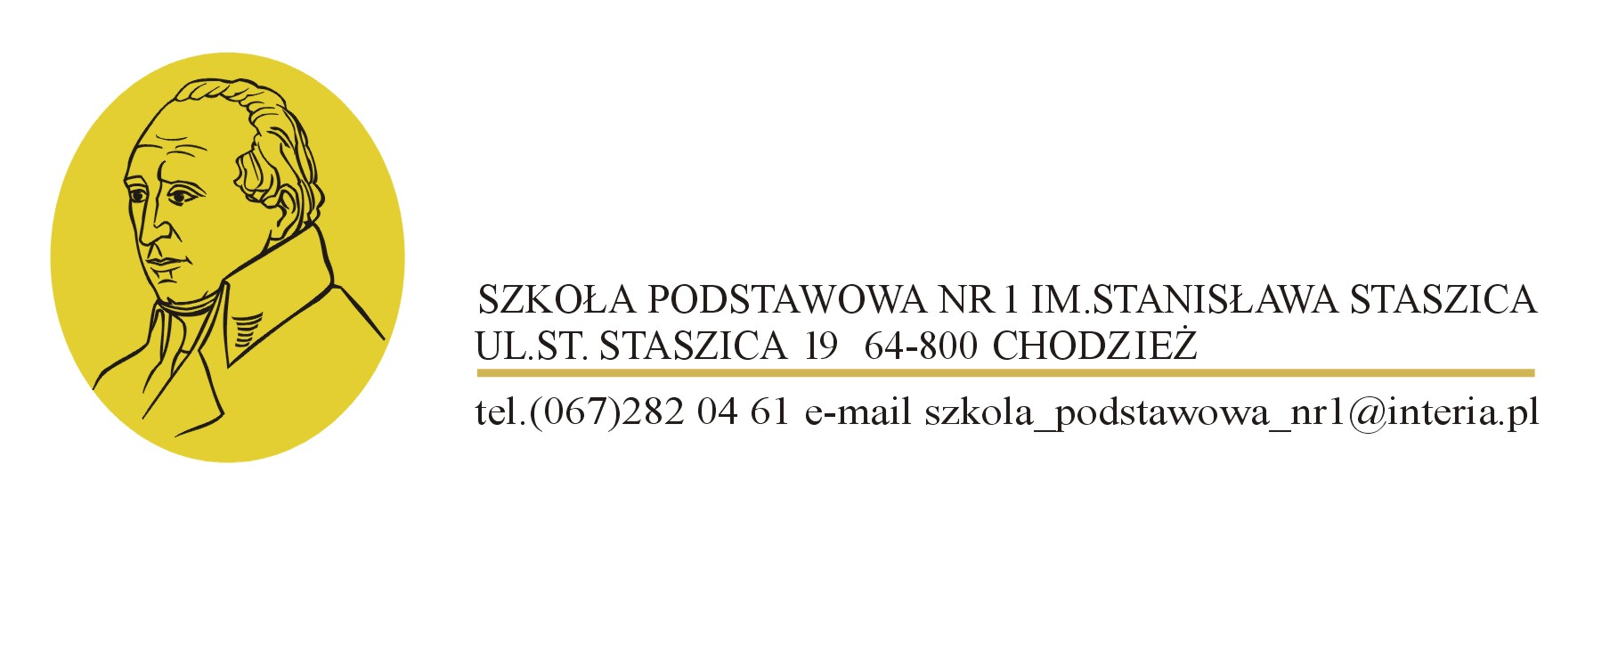

A primary school in Chodzież from Wielkopolska Region in Poland is looking for partner schools from Greece, Italy, Spain, the United Kingdom of Great Britain, Northern Ireland but also other European countries to start up a cultural and linguistic exchange with sport dimension.

The school was set up in 1903. The aim of the school is to gain experience through an international exchange. The school is being modified all the time in order to shape an innovative area of education. Due to the creation of sport classes where children can practice football, swimming, finswimming, volleyball, basketball, dance and gymnastics and cooperation with a local football club there is a strong emphasis on physical development. There are also swimming classes with one of the best swimming and finswimming trainers in Poland. The school invests in innovation and strive for improving sport classes so that the school footballers attend football trainings regularly. **Furthermore, there is a great emphasis put on foreign languages, e.g. English, German and Spanish are taught in the school.**

The school in Chodzież takes part in many projects and programmes which motivate pupils and teachers to achieve better results. The school has participated in competitions such as “a school of a good upbringing” and “**eSchool Wielkopolska – Digital Children’s Encyclopedia of Wielkopolska”.**

**Planned activities in the scope of the project:**

* mutual visits,
* becoming familiar with different habits and customs
* polishing up English, German and Spanish
* cultural exchange
* the development of sport’s activities, we can offer lessons with high – qualified teachers
* visiting different places and the expansion of pupil’s knowledge about history, geography

**The purposes of the project:**

* to help pupils in acquiring new various experiences which can influence positively on their life
* to boost the pupil’s awareness of sport
* to exchange ideas and gain knowledge on how to be an effective and qualified sportsmen
* to practice foreign languages and help pupils to feel more confident in a multicultural environment

All interested partners are invited to contact until **28 Febraury 2017**:

Agnieszka Wieczorek

Wielkopolska Region Brussels Office

Email: [agnieszka.wieczorek@wielkopolska.eu](mailto:agnieszka.wieczorek@wielkopolska.eu)